 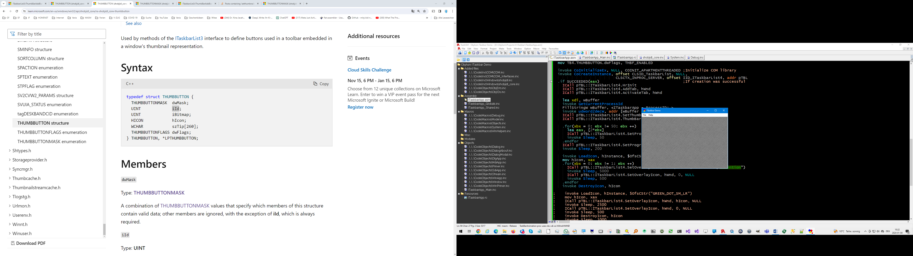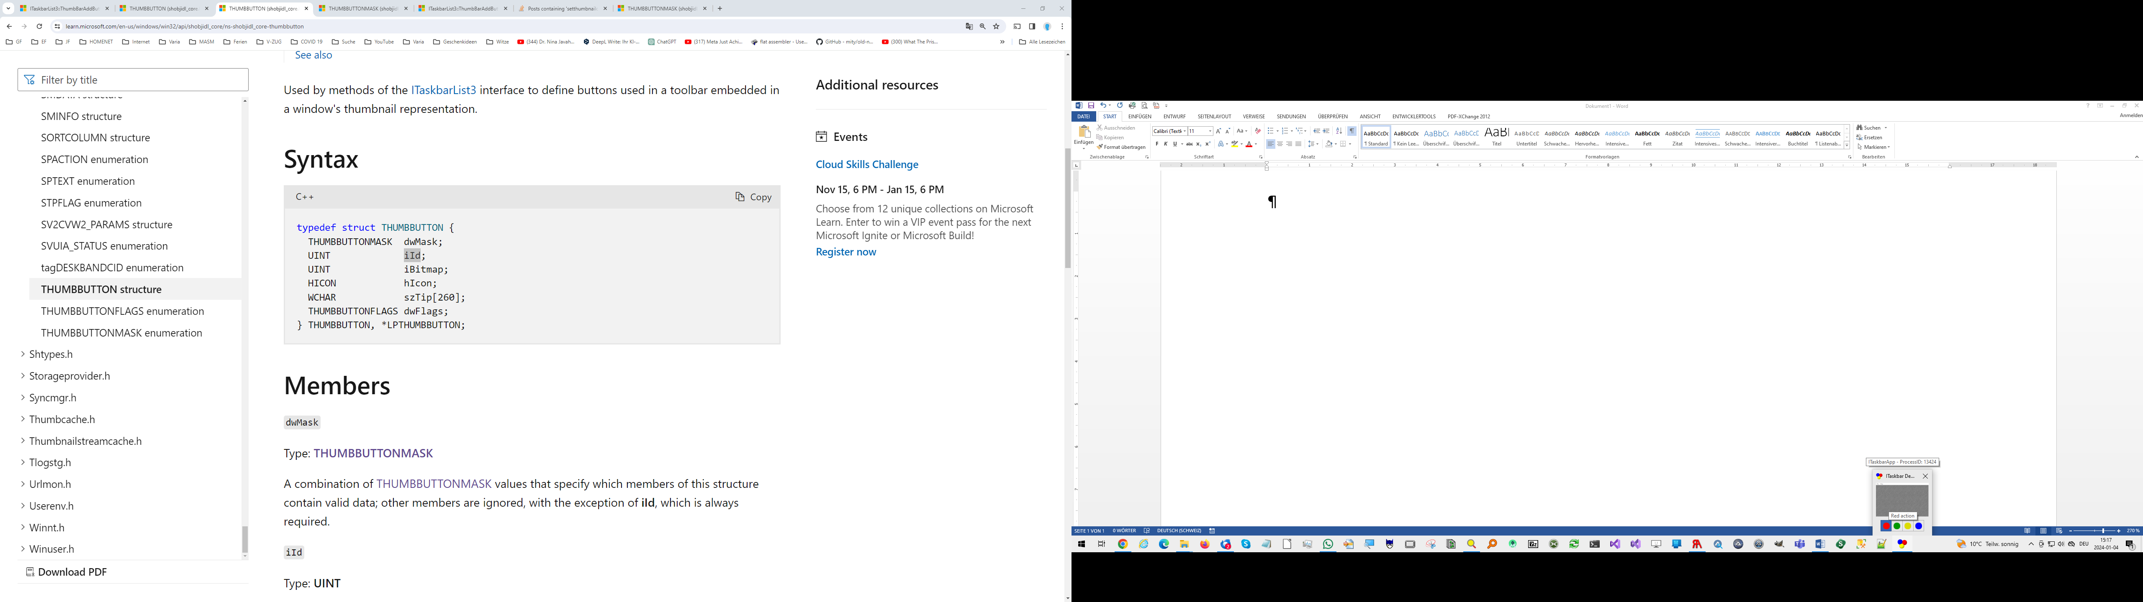

Animated Dot  
**Taskbar Tab**

Thumbnail Tooltip

4 ThumbBar Buttons

ThumbBar Button Tooltip